|  |  |  |  |  |  |  |  |  |  |  |  |  |  |  |  |  |
| --- | --- | --- | --- | --- | --- | --- | --- | --- | --- | --- | --- | --- | --- | --- | --- | --- |
| **Tipo de Registro** | | | | | | | | | | | | | | | | |
|  |  |  | **01 Director Responsable de Obra** | | | | |  | |  |  | **03 Corresponsable de Seguridad Estructural** | | | | |
|  |  |  |  | | | | |  | |  |  |  | | | | |
|  |  |  | **02 Corresponsable de Diseño** | | | | |  | |  |  | **04 Corresponsable de Instalaciones** | | | | |
|  |  |  | **Urbano y Arquitectónico** | | | | |  | |  |  |  | | | | |
|  |  |  | ***Inscripción*** | | | | |  | |  |  | ***Reinscripción*** | | | | |
|  |  |  |  | | | | |  | |  |  |  | | | | |
|  | | | | | | | | | | | | | | | | |
|  | | | | | | | | | | | | | | |  | |
| **NOMBRE COMPLETO** | | | | | | | | | | | | | | | **FECHA** | |
|  | | | | | | | | | | | | | | | | |
|  | | | | | | |  | | | | | | | |  | |
| **PROFESIÓN** | | | | | | | **MUNICIPIO** | | | | | | | | **ESTADO** | |
|  | | | | | | | | | | | | | | | | |
|  | | | | | | |  | | | | | |  | | |  |
| **DOMICILIO PARTICULAR (CALLE Y N°)** | | | | | | | **COLONIA** | | | | | | **C.P.** | | | **TELÉFONO** |
|  | | | | | | |  | | | | | |  | | |  |
|  | | | | | | |  | | | | | |  | | |  |
| **DOMICILIO FISCAL (CALLE Y N°)** | | | | | | | **COLONIA** | | | | | | **C.P.** | | | **TELÉFONO** |
|  | | | | | | | | | | | | | | | | |
|  | | | | | | | | | | | | |  | | | |
| **DIRECCIÓN ELECTRÓNICA** | | | | | | | | | | | | | **LUGAR Y FECHA DE NACIMIENTO** | | | |
|  | | | | | | | | | | | | | | | | |
|  | | | | | |  | | | | | | | |  | | |
| **INSTITUCIÓN EDUCATIVA DE EGRESO** | | | | | | **CÉDULA PROFESIONAL** | | | | | | | | **R. F. C.** | | |
|  | | | | | | | | | | | | | | | | |
| **FOTO RECIENTE**  **Y NITIDA** | | | |  | **IMPORTANTE**  **FIRMAR EXCLUSIVAMENTE**  **DENTRO DE LOS**  **LIMITES DEL**  **CUADRO** | | | |  | | | | | | | |
| **FOTO** | | | |  |  | | | | **FIRMA DEL SOLICITANTE** | | | | | | | |

**SOLICITUD**

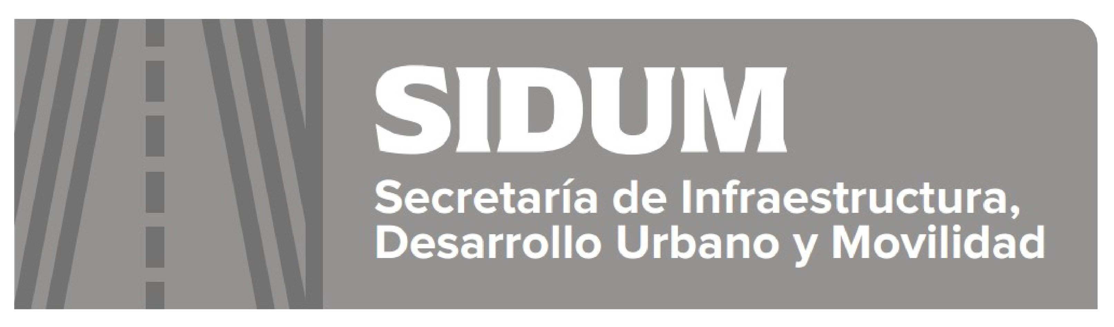



**Registro Estatal**

**de Directores**

**Responsables de Obra y**

**Corresponsables**

|  |  |  |  |  |  |  |  |  |
| --- | --- | --- | --- | --- | --- | --- | --- | --- |
|  |  |  |  |  |  |  |  | |
|  | | | | | | |  | |
| **Secretaría de Infraestructura, Desarrollo Urbano y Movilidad**  **Coordinación General de Gestión Urbana y Zonas Metropolitanas**  **Centro de Gobierno, Planta Baja, Bulevar Centenario de Torreón y Bulevar Fundadores**  **C. P. 25294 Saltillo, Coahuila. Teléfono (844) 698 10 00 Ext. 7277** | | | | | | | |  |